**EXERCISE: 01**

**DATE: 20.11.2020**

**AIM:**

To write a python program to print the calendar of a given month and year

**PROGRAM:**

import calendar

year=int(input())

month=int(input())

if(year<10000 and year>=1000 and month<=12 and month>=1):

print(calendar.month(year,month))

else:

print("Invalid Input")

**LINK:**

<http://103.53.53.18/mod/vpl/forms/submissionview.php?id=229&userid=1697>

**OUTPUT:**

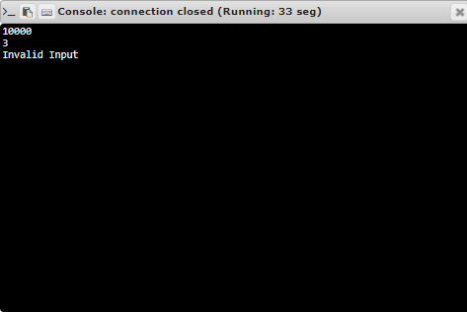

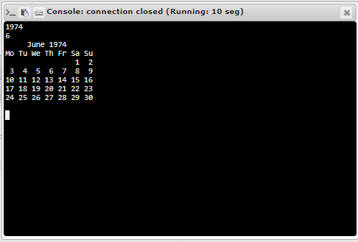

**RESULT:**

Thus the program is executed successfully